Love / Breakup Letter Exercise How-tos

|  |  |
| --- | --- |
| **Primary Goal** | To identify positive and negative attributes/elements/features in your brand, product, company, or event. |
| **When To Use** | During a kick-off session with a group that is familiar with a pre-existing concept, brand, event and/or application. |
| **Time Required** | 30-45 minutes |
| **Number of Participants** | 2 to 6 |
| **Who Should Participate?** | Stakeholders, Users, or Product Teams |
| What you need for this exercise | Pens or pencils, lined sheets of paper |

**Exercise steps**

1. Start with sharing a sample Love / Breakup letter with your participants
2. Write the Love / Breakup Letters
3. Read them Aloud
4. Follow-up interviews for clarification (if needed)

**Sample Love Letter**

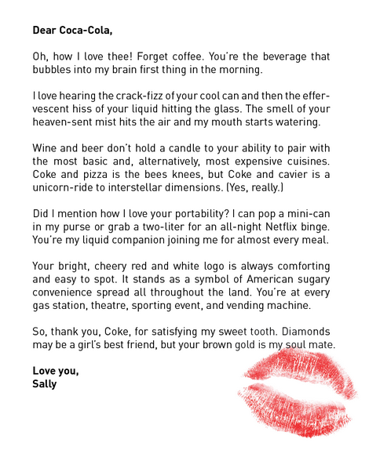

**Sample Breakup Letter**

